SVEUČILIŠTE U ZAGREBU
FAKULTET ELEKTROTEHNIKE I RAČUNARSTVA

ZAVRŠNI RAD br. xxxx
NASLOV ZAVRŠNOG RADA
Ime i prezime studenta

Zagreb, mjesec 20xx.
Završni rad predaje se u elektroničkoj verziji u pdf obliku.
Student u bazu učitava rad od četvrte stranice (Prazna stranica ili zahvala). Prve tri stranice (naslovnica, stranica istovjetna naslovnici, završni zadatak) bit će automatski povučene iz sustava.
Prilikom oblikovanja rada držite se redoslijeda. Redoslijed stranica okvirno je prikazan na slici.
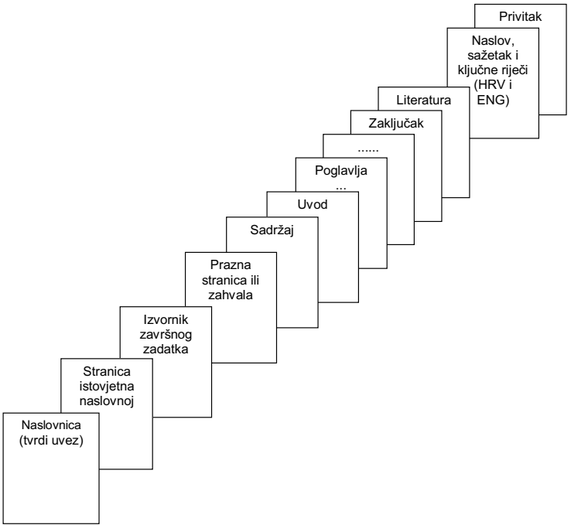

Student predaje samo pdf verziju rada preko FERweb-a.
Ova stranica treba biti:
ILI prazna stranica
ILI stranica sa zahvalom (po želji studenta; zahvala nije obvezna).

Sadržaj
Introduction 1
1. Specifikacija programske potpore 2
1.1. Use cases 2
1.2. Stilovi za tekst, naslove i podnaslove 2
1.3. Stilovi za nabrajanje 2
1.3.1. Stilovi za nabrajanje s točkama i crticama 3
1.4. Slike 4
1.5. Tablice 6
1.6. Matematički izrazi 7
1.7. Programski kôd 7
Zaključak 9
Literatura 10
Sažetak 11
Summary 12
Skraćenice 13
Privitak 14

Sadržaj se kreira automatski pomoću opcija References – Table of Contents – Insert Table of Contents. Nakon toga se otvara sljedeći prozor:
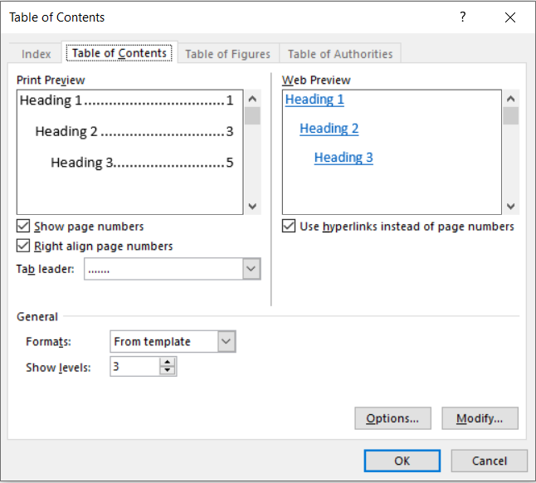
Za primjenu jednostavnog stila sadržaja (kao u ovom dokumentu), dovoljno je samo odabrati opciju [OK].

Introduction
Poglavlje Uvod treba dati kratak uvod (cca 1 stranica, max. 2) u završni rad.
Napomena: na naslov Uvod primijenite stil Heading 1, a zatim ručno maknite brojčanu oznaku.

U posljednjih nekoliko godina javio se veliki interes ljudi za fizičkim aktivnostima, posebice za onim samostalnim i individualnim, poput vježbanja u teretani ili vježbanju u prirodi. Ti ljudi svoje planove vježbanja i treninge moraju sastavljati sami, a to iziskuje mnogo vremena, razmišljanja i finalni produkt najčešće ispadne neorganiziran i nepotpun.
Također, budući da živimo u doba interneta i gdje su korisnicima dostupne raznovrsne vrste usluga putem Web aplikacija, kao rješenje bi trebala poslužiti Web aplikacije koja bi korisnicima omogućila jednostavnu organizaciju treninga.

U radu je prikazan proces izrade Web aplikacije za organizaciju i planiranje treninga, ali također se slična aplikacija može primjeniti za bilo koju vrstu osobnog planera aktivnosti te praćenje naprekta. Ideja za ovu vrstu Web aplikacije je potekla od autorskog dugogodišnjeg bavljenja vježbanjem, to jest preciznije, samostalnim vježbanjem u teretani. Iz iskustva se pokazalo da je proces izrade plana vježbanja i praćenje napretka kroz vrijeme dosta teško i neprecizno, te da iziskuje puno vremena, uzevši u obzir da se to vršilo korištenjem papira i olovke ili običnom excel tablicom. Također, pri bavljenju bilo kakvom aktivnosti, jako je važno praćenje vlastitog naprekta, kroz broj ponavljanja određene vježbe ili duljinu izvođenja. S obzirom na sve navedeno, javila se potreba za smanjenjem kompleksnosti takvih stavki, te se to može ostvariti pomoću navedene Web aplikacije.
Proces razvoja Web aplikacije će biti prikazan po fazama, koje se kreću od razrade specifikacije aplikacije kroz funkcionalne i nefunkcionalne zahtjeve, pa kroz arhitekturu i dizajn sustava, implementaciju i korisničko sučelje, sve do testiranja i puštanja u pogon.
Za izradu UML dijagrama za specifikaciju aplikacije i arhitekturu koristit će se alat Astah. Za pisanje izvornog koda za implementaciju, koristit će se Java Spring Boot (Java framework za programiranje poslužiteljske strane), Angular (TypeScript framework za programiranje klijentske strane), PostgreSQL (za kreiranje baze podataka), te Apache Web Server ( HTTP poslužitelj).
Cilj ovog završnog rada je izrada Web aplikacije za organizaciju i planiranje treninga, te za praćenje napretka i uvid u osobnu statistiku vježbanja.

Dodati
UML, short for Unified Modeling Language, is a standardized modeling language consisting of an integrated set of diagrams, developed to help system and software developers for specifying, visualizing, constructing, and documenting the artifacts of software systems, as well as for business modeling and other non-software systems. The UML represents a collection of best engineering practices that have proven successful in the modeling of large and complex systems. The UML is a very important part of developing object oriented software and the software development process. The UML uses mostly graphical notations to express the design of software projects

Specifikacija programske potpore
(Opis projektnog zadatka?)
Specifikacija programske potpore je proces određivanja potrebnih usluga i ograničenja u radu i razvoju sustava. Određuje se procesom inženjerstva zahtjeva, kojim se analiziraju, strukturiraju, dokumentiraju i provjeravaju korisnički zahtjevane usluge sustava te ograničenja u uporabi. Najveću pažnju ima klasifikacija zahtjeva s obzirom na sadržaj, tj. Funckionalni zahtjevi („system shall do“), nefunkcionalni zahtjevi („system shall be“) i zahtjevi domene primjene. Mi ćemo se fokusirati na funkcionalne zahtjeve.
Rad treba oblikovati kao dokument formata A4 pisan fontom veličine 12 točaka uz prored 1,5 redak, osim na mjestima na kojima je prikladniji drugačiji font i prored (npr., tablice, sheme, itd.).
U ovom poglavlju počnite s pisanjem rada.

Funkcionalni zahtjevi
Funkcionalni zahtjevi su izjave o uslugama koje sustav mora pružati, kako će sustav reagirati na određeni ulazni poticaj te kako bi se sustav trebao ponašati u određenim situacijama („system shall do“). Kako bi se dobro izlučili funkcionalni zahtjevi za ovu aplikaciju, prvo se moraju definirati dionici, tj svatko tko sudjeluje u projektu izrade programske potpore ili na koga taj projekt utječe. Zatim se definiraju funkcionalni zahtjevi, tj interakcije aktora sa aplikacijom.

Dionici:
- Administrator
- Korisnik
- Razvojni inženjer

Functional requirements and their actors:
- User (initiator) can:
- Login to the application
- View the data of:
- Workouts
- Exercises
- Scheduled workouts
- Statistics
- Create, update and delete data of:
- Workouts
- Exercises
- Scheduled workouts
- Administrator (initiator) can:
- Everything that user can
- Manage users:
- Register new users
- Remove users
- Database (participant):
  - Saves all data from the application
  - Deletes selected data
  - Updates selected data

Ovdje se piše tekst.

Use cases
A use case is a written description of how users will perform tasks on the website. It outlines, from a user's point of view, a system's behavior as it responds to a request. Each use case is represented as a sequence of simple steps, beginning with a user's goal and ending when the goal is fulfilled.
Use cases add value because they help explain how the system should behave and in the process, they also help brainstorm what could go wrong. They provide a list of goals and this list can be used to establish the cost and complexity of the system.
In this work, use cases describe a combination of the following elements: primary actor, goal, precondition, basic flow (main success scenario) and alternative paths (variations to the main success scenario).

Description of application’s use cases:
UC1 – Registration
- Primary actor: Administrator
- Goal: Registration of the new user
- Participants: Database
- Precondition: Administrator logged in
- Basic flow:
  - Administrator clicks on the account icon
  - Administrator selects “Register new user” from the menu
  - Registration form pop up window opens
  - Administrator inserts the new user data
  - Administrator submits the input
  - New user added to the database
  - Pop up window closes
  - Account menu closes
- Alternative paths:
3.a Administrator clicks outside the window
- Registration pop up window closes
5.a Administrator cancels the registration
- Registration pop up window closes
UC2 – Login
- Primary actor: User
- Goal: User login
- Participants: Database
- Precondition: User registered by administrator
- Basic flow:
  - User clicks selects the Login option
  - User is being redirected to the Login page
  - Login form is displayed
  - User inserts email and password
  - User submits the input
  - Database approves the credentials
  - User is being redirected to the Home page
- Alternative paths:
4. a Improper input
- User is not able to submit the input
5.a Given credentials are wrong
- Login page reopens

UC3 – Logout
- Primary actor
  - User
  - Administrator
- Goal: User login
- Participants: Database
- Precondition: User / Administrator logged in
- Basic flow:
  - User clicks on the account icon
  - User selects “Logout” from the menu
  - User is redirected to the Login page
UC4 – Exercises overview
- Main Actor: User
- Goal: Displaying a list of currently stored exercises
- Participants: Database
- Precondition: Login
- Basic Flow:
  - On the home screen, User selects the Exercises option
  - User is being redirected to the Exercise page
  - List of Exercises is displayed
UC5 – Filtering exercises
- Main Actor: User
- Goal: Displaying filtered exercises
- Participants: Database
- Precondition: Login
- Basic Flow:
  - On the home screen, user selects the „Exercises“ option
  - User is being redirected to the Exercises page
  - List of exercises is displayed on the page
  - User inserts filter in the filter input
  - Filtered exercises are displayed on the page
- Alternative path:
5.a No exercise shown for given filter

UC6 – Creating new exercise
- Main Actor: User
- Goal: Adding new exercise
- Participants: Database
- Precondition: Login
- Basic Flow:
  - On the home screen, User selects the Exercises option
  - User is being redirected to the Exercises page
  - User selects „Create new exercise“ option
  - A new window with the create form pops up
  - User inserts the data for the new exercise
  - User submits the input
  - New exercise created in the database
  - Pop up window closes
  - Exercises page refreshes with the changes
- Alternative path
6.a Exercise „Name“ input is left empty
- User is not able to submit the input
7.a Exercise name already exists
- Submit request is rejected

UC7 – Editing exercise
- Main Actor: User
- Goal: Editing chosen exercise
- Participants: Database
- Precondition:
  - User logged in
  - Exercise existing
- Basic Flow:
  - On the home screen, User selects the Exercises option
  - User is being redirected to the Exercises page
  - User selects the „Edit“ icon of the chosen exercise
  - The change form window pops up
  - User changes the desired exercise data
  - User submits the changes
  - Exercise is updated in the database
  - Pop up window closes
  - Exercises page refreshes with the changes
- Alternative path
4.a Exercise „Name“ input is changed to empty
- User is not able to submit the input
6.a Exercise name already exists
- Update request is rejected
6.b User cancels the changes
- Pop up window closes

UC8 – Deleting exercise
- Main Actor: User
- Goal: Deleting chosen exercise
- Participants: Database
- Precondition:
  - User logged in
  - Exercise existing
- Basic Flow:
  - On the home screen, User selects the Exercises option
  - User is being redirected to the Exercise page
  - User selects the „Delete“ icon of the chosen exercise
  - An alert window pops up
  - User confirms the deletion
  - Exercise is deleted from the database
  - Pop up window closes
  - Exercises page refreshes with the changes
- Alternative path
4.a User clicks outside of the pop up window
- Pop up window is closed
5.a User cancels the deletion
- Pop up window is closed

UC9 – Workouts overview
- Main Actor: User
- Goal: Displaying a list of currently stored workouts
- Participants: Database
- Precondition: User logged in
- Basic Flow:
  - On the home screen, User selects the Workouts option
  - User is being redirected to the Workouts page
  - Workouts list is displayed

UC10 – Filtering workouts
- Main Actor: User
- Goal: Displaying filtered exercises
- Participants: Database
- Precondition: Login
- Basic Flow:
  - On the home screen, user selects the „Exercises“ option
  - User is being redirected to the Exercises page
  - List of exercises is displayed on the page
  - User inserts filter in the filter input
  - Filtered exercises are displayed on the page
- Alternative path:
5.a No exercise shown for given filter

UC11 – Workout details overview
- Main Actor: User
- Goal: Displaying details for selected workout
- Participants: Database
- Precondition:
  - User logged in
  - Workout existing
- Basic Flow:
  - On the home screen, User selects the Workouts option
  - User is being redirected to the Workouts page
  - Workouts list is displayed
  - User clicks on the desired workout
  - Workout details are shown on the page

UC12 – Creating new workout
- Main Actor: User
- Goal: Adding new workout
- Participants: Database
- Precondition: User logged in
- Basic Flow:
  - On the home screen, User selects the Workouts option
  - User is being redirected to the Workouts page
  - User selects „Create new workout“ option
  - A new window with the create form pops up
  - User inserts the data for the new workout
  - User submits the input
  - New workout created in the database
  - Pop up window closes
  - Workouts page refreshes with the changes
- Alternative path
6.a Workout „Name“ input is left empty
- User is not able to submit the input
7.a Workout name already exists
- Submit request is rejected

UC13 – Editing workout
- Main Actor: User
- Goal: Editing chosen workout
- Participants: Database
- Precondition:
  - User logged in
  - Workout exists
- Basic Flow:
  - On the home screen, User selects the Workouts option
  - User is being redirected to the Workouts page
  - User selects the „Edit“ icon of the chosen workout
  - The change form window pops up
  - User changes the desired workout data
  - User submits the changes
  - Workout is updated in the database
  - Pop up window closes
  - Workouts page refreshes with the changes
- Alternative path
5.a Exercise „Name“ input is changed to empty
- User is not able to submit the input
6.a Exercise name already exists
- Update request is rejected
6.b User cancels the changes
- Pop up window closes

UC14 – Deleting workout
- Main Actor: User
- Goal: Deleting chosen workout
- Participants: Database
- Precondition:
  - User logged in
  - Workout exists
- Basic Flow:
  - On the home screen, User selects the Workouts option
  - User is being redirected to the Workouts page
  - User selects the „Delete“ icon of the chosen workout
  - An alert window pops up
  - User confirms the deletion
  - Workout is deleted from the database
  - Pop up window closes
  - Workouts page refreshes with the changes
- Alternative path
4.a User clicks outside of the pop up window
- Pop up window is removed
5.a User cancels the deletion
- Pop up window is removed

UC15 – Schedule overview
- Main Actor: User
- Goal: Displaying the current schedule
- Participants: Database
- Precondition: User logged in
- Basic Flow:
  - On the home screen, User selects the Schedule option
  - User is being redirected to the Schedule page
  - User schedule is displayed

UC16 – Adding workout to schedule
- Main Actor: User
- Goal: Adding workout to schedule
- Participants: Database
- Precondition:
  - User logged in
  - Workout exists
- Basic Flow:
  - On the home screen, User selects the Schedule option
  - User is being redirected to the Schedule page
  - User marks the wanted period on the schedule
  - Workout selection pop up window opens
  - User selects which workout to put in the schedule
  - User submits the changes
  - Pop up window closes
  - Scheduled workout is added to database
  - Schedule display updates
- Alternative path:
6.a User cancels the changes
- Pop up window closes

UC17 – Workout period change
- Main Actor: User
- Goal: Changing the period of workout
- Participants: Database
- Precondition:
  - User logged in
  - Scheduled workout exists
- Basic Flow:
  - On the home screen, User selects the Schedule option
  - User is being redirected to the Schedule page
  - User resizes the workout period box he wants to change
  - Scheduled workout is updated in the database
  - Schedule display updates

UC18 – Deleting scheduled workout
- Main Actor: User
- Goal: Deleting workout from schedule
- Participants: Database
- Precondition:
  - User logged in
  - Scheduled workout exists
- Basic Flow:
  - On the home screen, User selects the Schedule option
  - User is being redirected to the Schedule page
  - User selects the workout period box he wants to delete
  - User selects the “Delete” icon
  - Alert pop up window opens
  - User confirms deletion of the scheduled workout period
  - Pop up window closes
  - Scheduled workout is removed from the database
  - Schedule display updates
- Alternative path:
5.a User clicks outside of the window
- Pop up window closes
6.a User cancels the changes
- Pop up window closes

UC19 – Statistics overview
- Main Actor: User
- Goal: Displaying user workout statistics
- Participants: Database
- Precondition: User logged in
- Basic Flow:
  - On the home screen, User selects the Statistics option
  - User is being redirected to the Statistics page
  - User statistics are displayed
- Alternative path:
3.a No statistics available

Use cases diagram
A use case diagram is part of UML behavioral diagrams, which depict the elements of a system that are dependent on time and that convey the dynamic concepts of the system and how they relate to each other, such as graphical depiction of a user's possible interactions with a system, which was previously mentioned through the use cases, which are shown on the “Application use case diagram” (Figure 1.1).
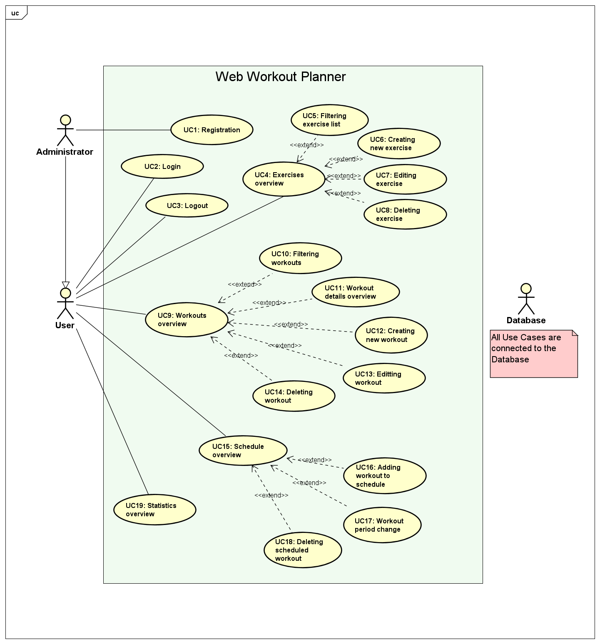
Figure 1.1 Application use case diagram

Stilovi za tekst, naslove i podnaslove
Stil (engl. style) je rezultat primjene niza naredbi o formatiranju na tekst. Primjenom stilova postižemo ujednačen izgled dokumenta. Za pisanje teksta i naslova u ovom su dokumentu na raspolaganju sljedeći stilovi:
- Normal
- služi za pisanje teksta
- Heading 1
- služi za pisanje naslova poglavlja (npr. 1. Naslov prvog poglavlja)
- Heading 2
- služi za pisanje podnaslova prve dubine (npr. 1.1. Prvo potpoglavlje)
- Heading 3
- služi za pisanje podnaslova druge dubine (npr. 1.1.1. Potpoglavlje niže razine)
- Podnaslov
- služi za pisanje podnaslova treće dubine (nenumerirano)
Napomena: nemojte kreirati dubinu poglavlja ispod treće (npr. 1.1.1.1) jer to nema smisla s obzirom na opseg rada kao takvoga.

Stilovi za nabrajanje
Prilikom nabrajanja poželjno je koristiti sljedeće stilove.

Stilovi za nabrajanje s točkama i crticama
Za nabrajanje po jednoj dubini i s točkom na početku koristi se stil:
bullet1
- Stavka 1
- Stavka 2
Ako autor želi dvije dubine nabrajanja, onda se to izvodi s pomoću dva stila:
bullet1 i bullet2
- Stavka 1
- Stavka 11
- Stavka 2
Postoje definirani i stilovi za nabrajanje s brojevima ili slovima:
bullet1brojevi
- Stavka 1
- Stavka 2
bullet1slova
- Stavka 1
- Stavka 2

Kod pobrajanja po brojevima ili slovima u drugoj dubini, mogu se koristiti sljedeći stilovi:
bullet1 i bulett2brojevi
- Stavka1
- Stavka 11
- Stavka 12
- Stavka 2
bullet1 i bullet2slova
- Stavka1
- Stavka 11
- Stavka 12
- Stavka 2

Slike
Prilikom izrade vlastitih crteža i slika (u odgovarajućem alatu ili u samom MS Wordu), treba voditi računa o tome da njihov sadržaj bude jasan i prilikom ispisa na crno-bijelom pisaču (ili fotokopiji). To se najlakše postiže bojanjem u sivim tonovima. Ako koristite razne boje, provjerite čitljivost i u crno-bijelom ispisu. U grafovima umjesto boja ili uz njih možete koristiti različite stilove crta (puna, isprekidana, ili s ugrađenim oznakama).
Nakon što ubacite sliku u tekst (kopiranjem ili putem izbornika Insert/Picture), selektirajte ju i na nju primijenite stil slika. Prema potrebi možete postaviti i položaj slike u odnosu na tekst tako da ponovno odaberete sliku (jednostrukim klikom lijevog gumba miša) i zatim u izborniku (desni gumb miša) odaberite opciju Format Object. U opciji Layout odaberite In line with text.
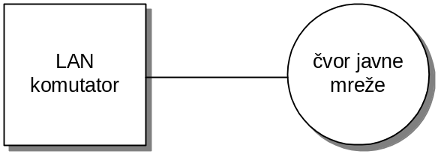
Sl. 1.1 Povezivanje LAN komutatora i javne mreže
Prilikom pripreme slika, preporučuje se da ih odmah pripremite u odgovarajućoj veličini, jer će povećavanje ili smanjivanje razgoditi veličinu slova. Za slike koje crtate u alatu Visio koristite osnovnu veličinu slova Arial 10 pt, ili, ako Vam trebaju manja slova (ovisno o veličini i složenosti slike), koristite Arial 8 pt.
Za ubacivanje kratkog opisa (ispod) slike treba selektirati sliku i u izborniku (desna tipka miša) odabrati opciju Insert Caption.
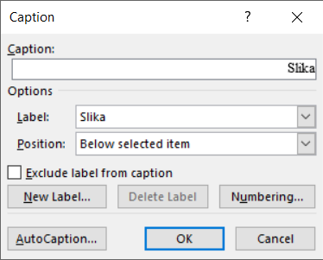
Sl. 1.2 Način postavljanja Captiona za sliku 1.2
Odaberite oznaku slike (Label) Sl. i potvrdite s OK.
Opcija Insert Caption će ubaciti dio teksta Sl. <broj>, nakon čega treba samostalno upisati tekst u nastavku (npr., za sliku 1.1, „Povezivanje LAN komutatora i javne mreže“).
Napomena: Kako bi slike bile numerirane kao <poglavlje>.<broj slike u tom poglavlju>, opciju Numbering u izborniku prozoru Caption treba podesiti kao na slici (Sl. 1.3).
Application Use Case Diagram 1.1
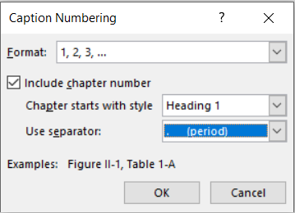
Sl. 1.3 Postavljanje opcije Numbering u prozoru Captioon
Svaka slika mora biti referencirana u tekstu. To znači da se na odgovarajućem mjestu u tekstu „pozivamo“ na sliku, kako bismo na nju usmjerili čitateljevu pažnju. Primjerice, kako bismo se pozvali na sliku 1.1, treba napisati željeni tekst, npr. „Primjer povezivanja čvora lokalne mreže s čvorom javne mreže prikazan je slikom ...“, zatim odaberemo opciju References i Cross-reference, nakon čega se otvori prozor kao na slici (Sl. 1.4). Odaberite opcije koje su prikazane na slici i kliknite na gumb Insert. Rečenica kojom se pozivamo na sliku treba doći ispred mjesta u tekstu gdje se slika pojavljuje te tako služi i kao svojevrsna najava (na primjer: „Provedeno je 100 mjerenja, a rezultati su obrađeni i prikazani grafički (Sl. x.y).“)
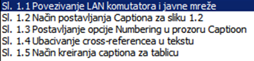
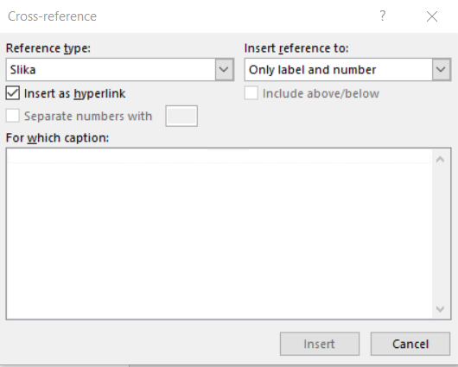
Sl. 1.4 Ubacivanje cross-referencea u tekstu
Sada će željeni tekst izgledati kao „Primjer povezivanja čvora lokalne mreže s čvorom javne mreže prikazan je slikom (Sl. 1.1).“

Tablice
Sličan način rada je i s tablicama. Na početku novog odlomka u koji želite postaviti tablicu, ponovo postavite stil slika. Umetnite tablicu i popunite stupce u njoj. Dodajte opis (iznad) tablice tako da označite tablicu i odaberete opciju Insert Caption (kao label odaberite Tablica).
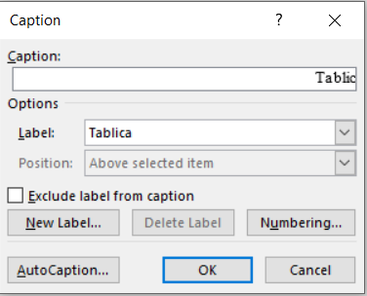
Sl. 1.5 Način kreiranja captiona za tablicu
U nastavku je prikazan primjer tablice.
Tablica 1.1 Parametri prijenosnog linka
prijenosna brzina | širina prijenosnog pojasa
Način referenciranja tablica u tekstu isti je kao i za slike.

Matematički izrazi i formule
Matematički izrazi obilježava se brojem u zagradama, uz desni rub stranice, a u tekstu se poziva na broj izraza (na primjer: „Kapacitet kanala C računa se prema izrazu (1).“)
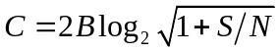 | (1)
Osnovni stil pisanja je Times New Roman 12 pt.

Programski kôd
Programski kôd može biti označen brojem kao tablica ili slika (ako je opsežniji), ili može biti samo umetnut u tekst (ako se radi o nekoliko redaka).
Više redaka koda (stil Kôd):
char *trazizad(char *text, char znak) {
char *t;
if(*text == '\0')
return NULL;
t = trazizad(text+1,znak);
if(t != NULL)
return t;
if(*text == znak)
return text;
return NULL;
}
Kôd 1.1 – Program za pronalazak pozicije zadnjeg pojavljivanja znaka u nizu
Nekoliko linija koda:
int nazivVarijable;
nazivVarijable = funkcijaRacunajFaktorijele(5);
Ako se neki kod (npr. naziv klase, varijable ili metode), npr. nazivVarijable pojavljuje unutar teksta onda se to treba označiti stilom Kôd u tekstu.

Zaključak
Na kraju rada piše se kratak zaključak, duljine do najviše jedne stranice.

Literatura
Popis literature dolazi na kraju rada, iza zaključka, a prije ostalih priloga.
Na naslov Literatura primijenite stil Heading 1, a zatim ručno maknite brojčanu oznaku (to je važno kako bi i naslov „Literatura“ ušao u sadržaj na početku rada, prije uvoda).
Pri kreiranju navoda u popisu literature koristite stil literatura.
Primjeri u nastavku ilustriraju navođenje raznih izvora u popisu literature: (1) knjige, (2) članka u časopisu, (3) članka u zborniku konferencije, (4) doktorskog, magistarskog ili diplomskog rada, (5) web-stranice.
- Tanenbaum, A. S., Wetherall, D. J. Computer Networks. 5. izdanje. London: Pearson, 2013.
- Brady, P.T. A Statistical Analysis of On-off Patterns in 16 Conversations, Bell System Technical Journal, 47,1 (1998), str. 55-62.
- Brady, N. A Statistical Analysis of Use Case. Proceedings of the 7th International Conference on Telecommunications ConTEL, Zagreb, (2003), str. 45-52.
- Ivić, M. Analiza ponašanja korisnika u digitalnim igrama namijenjenima učenju. Diplomski rad. Sveučilište u Zagrebu Fakultet elektrotehnike i računarstva, 2016.
- Epstein M., The best VR headset in 2019, PC Gamer, (2019, listopad). Poveznica: https://www.pcgamer.com/best-vr-headset/; pristupljeno 4. listopada 2019.

Uz svaki preuzeti sadržaj u svom radu – bilo da je riječ o tekstu (izravno citiranome ili „prepričanome“), slici ili grafičkom prikazu – treba navesti oznaku izvora (članak, knjiga, web-stranica ...) u popisu literature te se na nju „pozvati“, na primjer:
Međusobno povezivanje mreža zasniva se na primjeni komunikacijskih protokola (Tanenbaum i Wetheral, 2014).
Podaci o karakteristikama uređaja za virtualnu stvarnost preuzeti su s portala PC Gamer [5].
Početna verzija programa preuzeta je iz diplomskog rada [5].
U danim primjerima mogli ste uočiti dva načina referenciranja:
- (Tanenbaum i Wetheral, 2014),
- [1].
Kad izaberete jedan od njih svakako ga se držite konzistentno u cijelome radu.

Sažetak
Naslov, sažetak, ključne riječi (na hrvatskom jeziku)
Sažetak opisuje sadržaj rada, prepričan u stotinjak riječi.

Summary
Title, summary, keywords (na engleskom jeziku)

Skraćenice
Ovo poglavlje nije obavezno, ali se može dodati radi preglednosti.

ATM Asynchronous Transfer Mode asinkroni način prijenosa
ISDN Integrated Services Digital Network digitalna mreža integriranih usluga

Napomena: na naslov Skraćenice primijenite stil Heading 1, a zatim ručno maknite brojčanu oznaku (to je važno kako bi i skraćenice ušle u sadržaj na početku rada, prije uvoda). Pri kreiranju popisa skraćenica koristite stil nabrajanje.

Privitak
Privitak je također opcionalno poglavlje (u dogovoru s mentorom).
Sadržaj koji se stavlja u privitak je, općenito, nešto što je, kao cjelinu, prikladno izdvojiti iz sadržaja samog rada.
Mogući primjer je tehnička dokumentacija vezana uz završni rad - npr. električka i položajna shema sklopa, sastavnica, predložak tiskane veze, plan bušenja, ispis programa s detaljnim opisom.
Drugi primjer uključuju upute za korištenje rezultata rada (softvera ili hardvera), detaljni ispisi mjerenja čiji su rezultati sažeto ili grafički prikazani u radu. Ako se radi o softveru, uobičajeno je navesti podatke o platformi na kojoj se izvodi (npr., karakteristike uređaja i operacijskog sustava te pomoćnog softvera), kao i upute za instalaciju.

U privitku nemojte koristiti stilove razine Heading, već samo (nenumerirani) stil Podnaslov.
Na primjer:
Instalacija programske podrške

Upute za korištenje programske podrške
.
.
.
Ostali savjeti
U izborniku Tools - opcija Language postavite Croatian kao default jezik. Na kraju provedite strojnu provjeru teksta (spell checking, ako ga imate ugrađenoga), ali svakako pažljivo i pročitajte vlastiti tekst.
Ako nemate ugrađeni spelling checker za hrvatski jezik, možete se poslužiti Hascheckom (izgovara se Hašek, a ime dolazi od kratice za Hrvatski akademski spelling checker), dostupan putem poveznice https://ispravi.me/.

